|  |  |  |  |
| --- | --- | --- | --- |
|  | 2019-06-13 |  | |
|  | |  | |
| Final Project  빅데이터시스템설계 | | | |
|  |  | |  |
|  |  | | 소프트웨어학과  2014041030 손광호  2014041044 박찬용 |

목차

1. Requirement Analysis 2

2. Crawler 3

3. MongoDB storage 3

4. Queries 5

5. Source code 6

# 1. Requirement Analysis

ㆍNon-member users can create an account.

ㆍMembers can log in with his(her) registered ID, PW.

ㆍAll user can view the entire game list.

ㆍAll user can view a list of games by genre.

ㆍAll user can search by game name on game list page.

ㆍNon-member users can view 6 latest games on the main page.

ㆍMembers can view 6 recommended new games on the main page.

ㆍAll user can view the game detail by clicking the game image or the game name.

ㆍAll user can compare prices by site on the game detail page.

ㆍAll user can go to the game sale site by clicking the game sale site name.

ㆍMembers can bookmark their favorite games

ㆍMembers can view bookmarked game list.

ㆍMembers can remove their games which is bookmarked

ㆍMembers can view the game genre preference in a pie graph on my page.

ㆍMembers can view the game publisher preference in a pie graph on my page.

# 2. Crawler

* Attached file.

# 3. MongoDB storage

* Attached file.

Game Inform

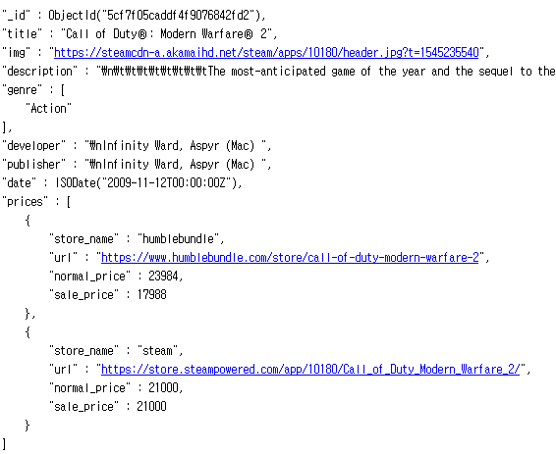

User

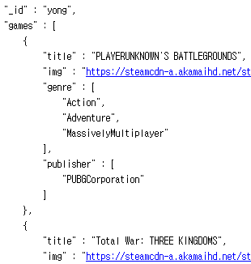

# 4. Queries

### Main page

1. Non-member



2. Member

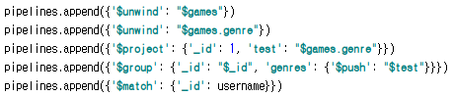



### Game list



### Game list by genre



### Bookmark



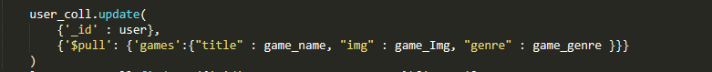

### Game Detail



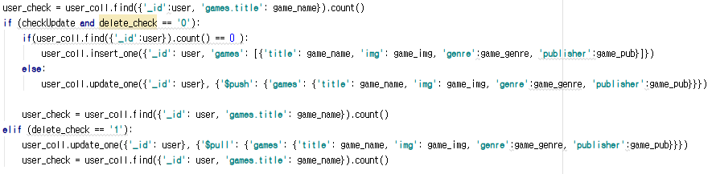



### My page



# 5. Source code

* Attached file.